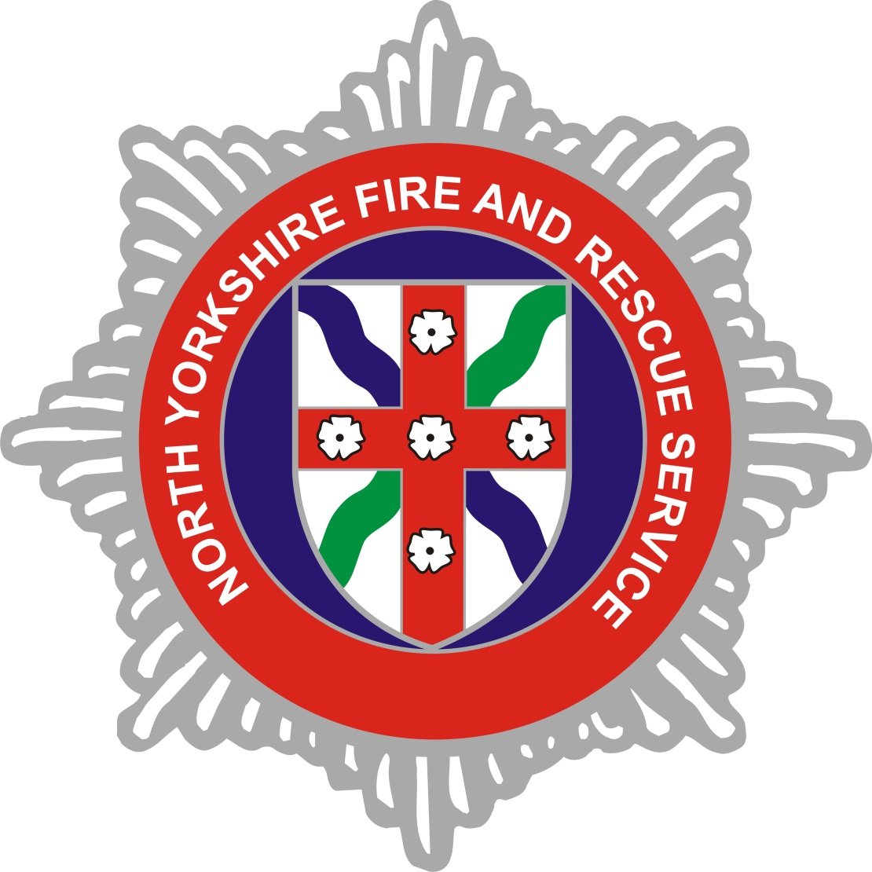
North Yorkshire Fire and Rescue Service Gender Pay Gap Report
2018

Introduction

This report covers North Yorkshire Fire and Rescue Service’s (NYFRS) obligations under the Equality Act 2010 (Gender Pay Information Regulations 2017) to publish an annual Gender Pay Gap report. The snapshot date is 31/03/2018. This is the key date for which many of the details required to undertake the calculations come from and it is also the date by which NYFRS must publish their report.

Gender pay reporting is a different requirement to carrying out an equal pay audit. It is not a review of equal pay for equal work but, instead, compares hourly rates of pay and bonuses staff may receive by gender, and identifies if there are any imbalances in pay.

We have conducted our analysis in line with gender pay gap regulations which require disclosure of data for all UK legal entities employing more than 250 employees. The report is published both internally and externally.

As part of the report, the Service is required to provide an explanation of the cause of any pay gap. The information is used to look at any gender imbalance across the workforce and the balance of male and female employees across different levels.

The Service is required to publish the following information:

- Mean gender pay gap
- Median gender pay gap
- Mean bonus gender pay gap
- Median bonus gender pay gap
- Proportion of males and females receiving a bonus payment
- Proportion of males and females in each pay quartile

Mean gender pay gap | The difference between the mean hourly rate of pay of  male employees and that of female employees as a  percentage.
Median gender pay gap | The difference between the median hourly rate of pay of  male employees and that of female employees as a  percentage.
Mean bonus pay cap | The difference between the mean bonus pay paid to male employees and that paid to female employees as a  percentage.
Median bonus gap | The difference between the median bonus pay paid to  male employees and that paid to female employees as a  percentage.
Bonus Proportions | The proportions of male and female relevant employees  who were paid a bonus during the relevant period.
Quartile Pay Bands | The proportions of male and female employees in the  lower, lower middle, upper middle and upper quartile pay bands
Gender Pay Gap
A gender pay gap shows the difference between the average hourly earnings of men and women. This is expressed as a percentage of men’s earnings e.g. a gender pay gap of 18% indicates women earn 18% less on average than men.

Workforce Information
A wide definition of who counts as an employee is used. For North Yorkshire Fire and Rescue Service this includes all employees under “Green Book” (Support Staff) and “Grey Book” (Operational and Control Staff) terms and conditions.
As of 31 March 2018 the total headcount contained within the workforce definition as above was 759, of which 12% were women.
The below table shows a comparison of headcount across 2017-18 and 2018-19.
North Yorkshire Fire and Rescue Staff
 | 2017-18 | 2018-19
Gender | Employees | *Employees
Female | 94 | 91
Male | 691 | 668
Total | 785 | 759

*Note
7 female and 6 male members of staff have been removed from the headcount figures as a result of being paid less than their usual basic pay due to being on leave. For the purposes of gender pay gap reporting, leave is interpreted broadly to include:
- annual leave;
- maternity, paternity, adoption, parental, or shared parental leave;
- sick leave;
- special leave;
- any other form of leave (e.g. study leave or sabbaticals).
A further 10 male employees received no pay at all during the relevant pay period and, in accordance with the regulations, are excluded from the gender pay gap calculations. These employees are all volunteer firefighters.

Mean and Median Pay Gap
The mean (average pay gap is) 10.22%

Median is the midpoint of the data the median pay gap is 3.24%

 | Female | Male | Gap | %
Average hourly rate (mean) | 13.35 | 14.87 | -£1.52 | 10.22%
Median hourly rate | 13.46 | 13.91 | -£0.45 | 3.24%

The 2017 UK national median pay gap was 18.4% (as published in Spring 2018). The median pay gap between men and women within North Yorkshire Fire and Rescue Service (NYFRS) in 2018 is 3.24%, which is considerably lower than the UK average of the previous year.

Corporate Management Board (CMB)

CMB is made up of seven members of staff. Six of which are male and one female. For the purposes of the report, roles within CMB include: Chief Fire Officer, two Assistant Chief Officers, two Area Managers, Head of Finance and Administration and Head of Technical Services.

Median Gender Pay Gap – CMB
Male median | £43.39
Female median | £31.48

The median pay gap for CMB is 27.45%.

Salary Quartile Bands
Salary Quartile Bands | Hourly Rate Range (£) | Female  (Count) | Female % | Male  (Count) | Male % | Total  (Count)
1  High | 15.63 – 69.42 | 18 | 9.47% | 172 | 90.53% | 190
2  Mid Upper | 13.91-15.63 | 20 | 10.53% | 170 | 89.74% | 190
3  Mid Lower | 11.74-13.91 | 13 | 6.84% | 177 | 93.16% | 190
4  Low | 8.19- 11.74 | 40 | 21.16% | 149 | 78.84% | 189

Women are represented at all levels across the organisation, including the Services Corporate Management Board.

The support staff composition is more evenly balanced and is represented by 65.5% of women compared to 4.76% of women in the operational workforce (Firefighter and Control Staff).

The high quartile illustrates the highest earners in NYFRS and contains 19.78% of the female workforce compared to 25.75% of the male workforce.

The highest numbers of females are in the mid upper quartile which contains skilled roles, the majority of which are from within the Support Staff group.

NYFRS has a high proportion of staff from the Retained Duty System. This group of staff respond to station to station on a pager system and usually have a primary employment as well as a Retained Duty System (on-call) contract. This staff group equates to 47.29% of the total workforce, and are placed largely in the mid and lower quartiles. Women make up 3.06% of the Service’s on-call firefighters.

The Service has rolling recruitment for on-call staff employed under the Retained Duty System terms and conditions however, as this staff group is constrained by locality to the fire station, the recruitment pool for this group is often limited.

Bonus Payments
The only payments made to NYFRS employees that meet the definition of bonus pay in the regulations are those made under the Continual Professional Development (CPD) scheme for uniformed Firefighters.

This scheme is designed to recognise and reward experienced employees who demonstrate continual professional development over and above that required at competent level by the national occupational standards. Successful applicants are awarded a set annual figure which is determined each year by the national joint council on local authority fire and rescue services.

Proportion of Staff Receiving a Bonus Payment
Male | 40.12%
Female | 16.48%

Bonus Payment Gap
Mean Gap | -17.11%
Median Gap | 0%

The bonus pay gap is -17.11% at the mean and 0% at the median which presents a mixed picture. The reverse mean bonus pay gap is driven by a number of factors, including:

- there are only 15 women who received CPD payments during the twelve month period ending with the snapshot date. All were wholetime or full-time members of control staff;

- 268 men received CPD payments during the twelve month period ending with the snapshot date. Of these 268 men who received CPD payments, 50 are on-call firefighters who receive one quarter of the set annual CPD amount applicable to wholetime firefighting staff and thus reduce the mean average.
Conclusion
North Yorkshire Fire and Rescue Service’s mean gender pay gap is 10.22%.

Whilst the Service continues to work on increasing the diversity within its workforce, the proportion of male to female staff members is significantly higher.

The largest proportion of the workforce are ‘Grey Book’ members of staff. In particular there are a high number employed as On-Call firefighters and, within this staff group, there is a significantly higher proportion of men than women.

The reasons for the gap are well known to NYFRS and the Fire and Rescue Service Sector generally. The Service values and encourages diversity in all roles and at every level and action is underway to encourage the recruitment and retention of female members of staff, particularly in ‘Grey Book’ roles where there is a high underrepresentation.

The impact of initiatives to recruit and retain female members of staff will take time and the Service recognises the benefit of continuing to take positive steps to close the gap. NYFRS is committed to the principles of equality of opportunity and we employ and promote staff in a fair and consistent manner and based on competency.

The Service will continue to focus on taking positive steps to improve the gap. We will continue to monitor our workforce, continue to value and encourage diversity in recruitment and have working practices that support balancing work and personal life. The Service uses job evaluation to ensure a fair pay structure. For Grey and Green book staff, the rates of pay are equal for men and women. Job evaluation will continue to be used and all processes and initiatives will be reviewed to ensure that we are continuing to take positive steps in closing the gap.

Declaration

I confirm that the information and data provided is accurate and in line with mandatory requirements.

A Brodie
Chief Fire Officer for North Yorkshire Fire and Rescue Service

